Your Rights and Responsibilities

Goulburn Options works to provide you with the best supports possible. To help us improve these supports, you can take some time to learn about your rights and responsibilities as a participant.

At Goulburn Options, you have the Right to:
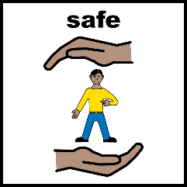

- Feel Safe
- Be treated with respect at all times, fairly and without discrimination
- Access service in a safe and healthy environment
- Develop and maintain your personal identity (including gender, sexuality, cultural, religious and spiritual identity)
- Access and maintain connection to community, family and friends
- Choose your supports
- Refuse a service
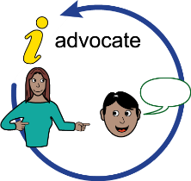
- Ask an advocate to speak for you
- See any of your personal information at any time (just ask a member of Goulburn Options’ staff)
- Refuse to allow certain people to look at your personal information, or to have your personal information shared with other people
- Refuse to work with any students on placement
- Refuse to allow staff to access your home or personal belongings
- Receive 24hrs notice (where possible) if a support has been cancelled or changed
- Provide a complaint or feedback to the organisation at any time

At Goulburn Options, you have the Responsibility to:
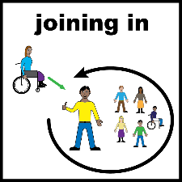
- Participate in the supports you have chosen, or else let Goulburn Options know if you plan to be away from your supports
- Be respectful to your staff and other participants at all times
- Let your staff know if you are sick
- Tell your staff if your personal information changes, such as the medication you take, your phone number, or home address
- Make sure you pay any out-of-pocket costs
- Tell your staff if you have a problem, some feedback, or a complaint
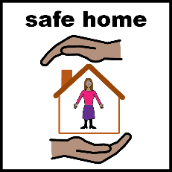
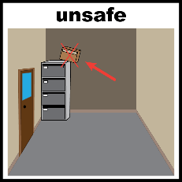
- Tell your staff if you see something that is unsafe
- Make sure staff are safe whilst working with you in your home (make sure the environment is appropriate for work)

