Statement of Commitment to the Safety and Wellbeing of Children

Goulburn Options acknowledge its responsibility to uphold and promote the safety and wellbeing of children and young people, and to respect, listen to the opinions of the children and young people in our care.

Goulburn Options recognises the importance of developing and implementing systems which protect children and young people from risk of harm, and fostering a culture of safeguarding children and young people.

Goulburn Options commits to the following principles:
- Respect: We will treat everyone equally, regardless of who they are or their age. We will ensure that everyone feels safe, welcome, and respected.
- Inform: We will ensure that children and young people are informed of their physical, emotional and online rights and what actions to take if they feel unsafe.
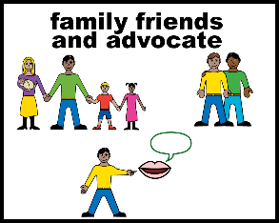
- Family and community: Where it is safe to do so, we will involve families and communities in our approach to child safety and wellbeing.
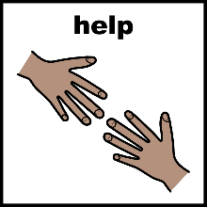
- Help: We will help children and young people to work towards their goals in life.

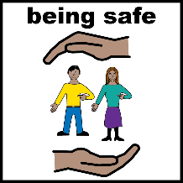
- Safety: We will ensure that children and young people are safe and comfortable in our care. All persons in our organisation will be supported to safely disclose risks of harm to children and young people. We will take seriously, and act immediately in relation to any reports of child abuse.
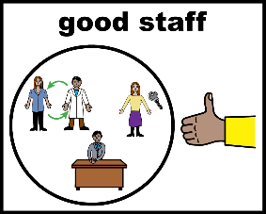
- Staff and volunteers: We will ensure that all workers whom we engage have been appropriately screened and trained to work positively with children and young people.
- Include children in decisions: We will seek input and feedback from children and young people and empower them to participate in decisions affecting their lives or care.
- Give voice: We will help children and young people to voice their concerns and complaints about the organisation, and we will take their input seriously.
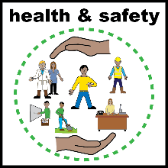
- Safe environment: We will ensure that our physical and online environments promote safety and wellbeing.

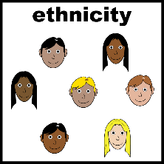
- Cultural Safety: We will ensure the cultural safety of Aboriginal and Torres Strait Islander children. We will ensure that all children, including Aboriginal and Torres Strait Islander children are provided with a safe, nurturing, and positive environment where they are comfortable with being themselves, expressing their culture and are supported by a carer that encourages their sense of self and identity.

- Policies and procedures: We will document, regularly review, and continuously improve our policies and procedures to promote and uphold child safety and wellbeing.

